S3 CONCEPTS AND DNS IN AWS
Agenda
- Creating Folders and Uploading Data
- Versioning in S3
- Cross-Region Replication
- Transfer Acceleration
- DNS
- Amazon Route 53
- Route 53 Dashboard
Creating Folders and Uploading Data:
Step 1: Go to the previously created Bucket and click on it after which Objects present in that Bucket will appear
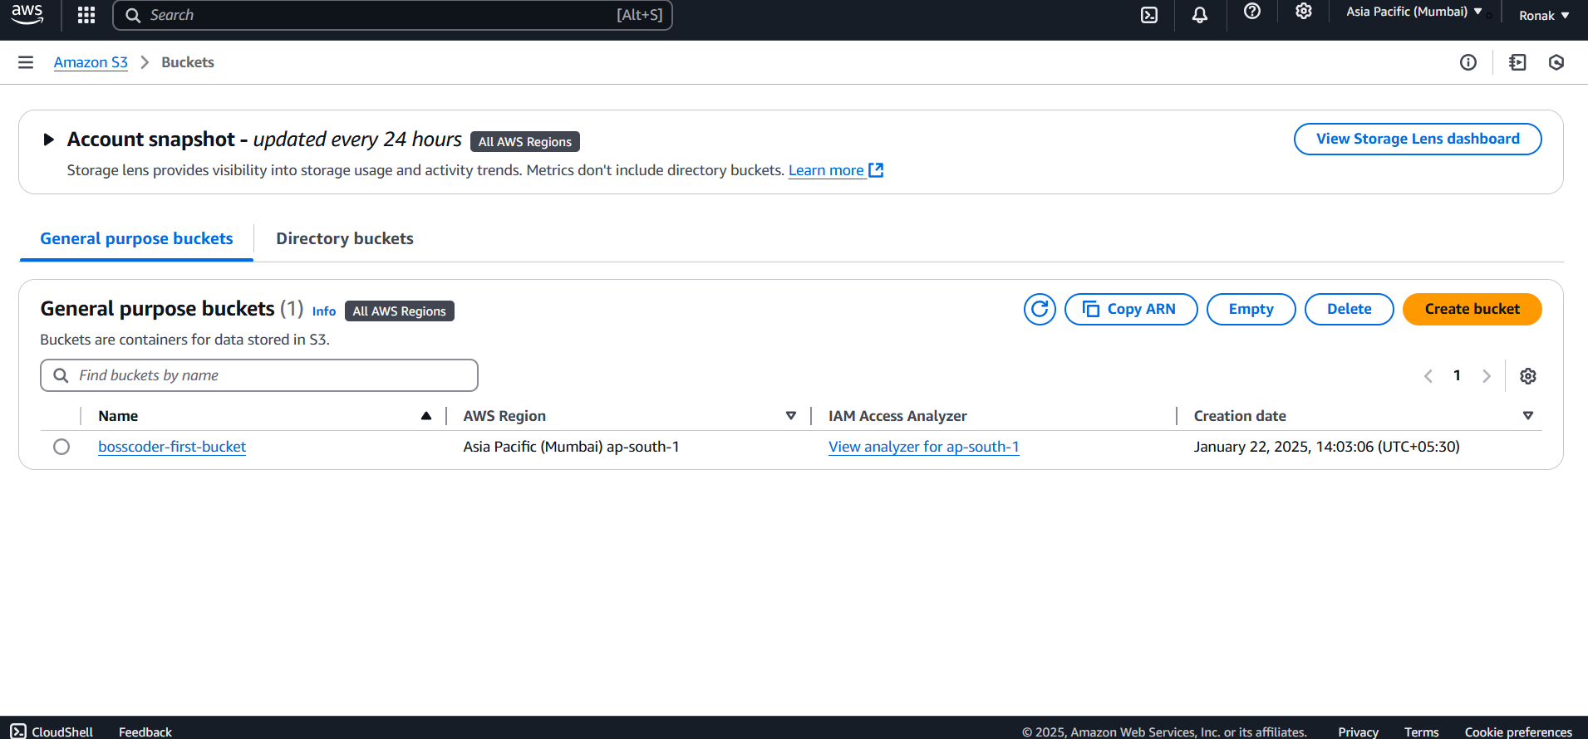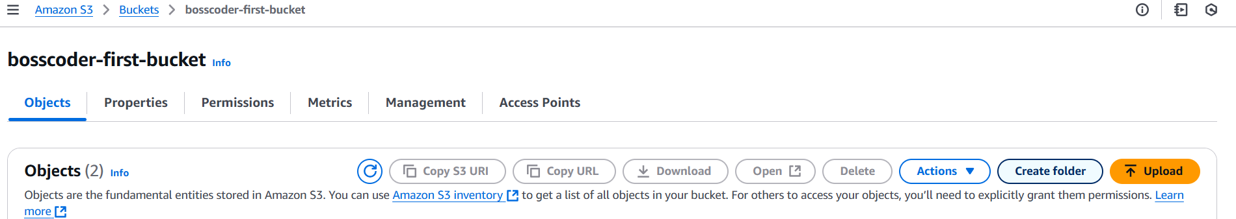
Step 2: Now, create a Folder and its name will appear in the Objects list.
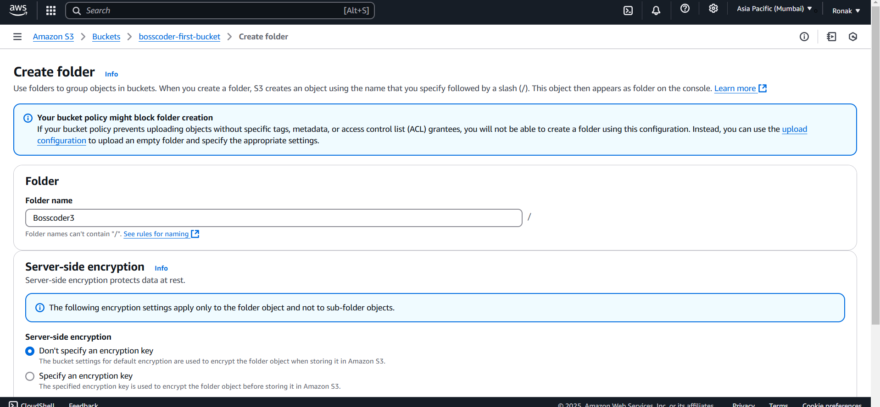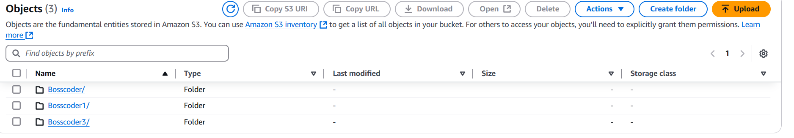
NOTE:
- Bucket: A bucket is the top-level container in Amazon S3. Think of it as a root directory where all your objects (files) and folders reside. Each bucket has a unique name within the AWS global namespace.
- Folders: Folders in S3 are a logical construct to organize objects within a bucket. They are not real directories like in a traditional filesystem but are simulated using prefixes in the object's key (file path).
Step 3: To upload data directly instead of Folders, you can go to the Upload option and upload the data you want to upload.
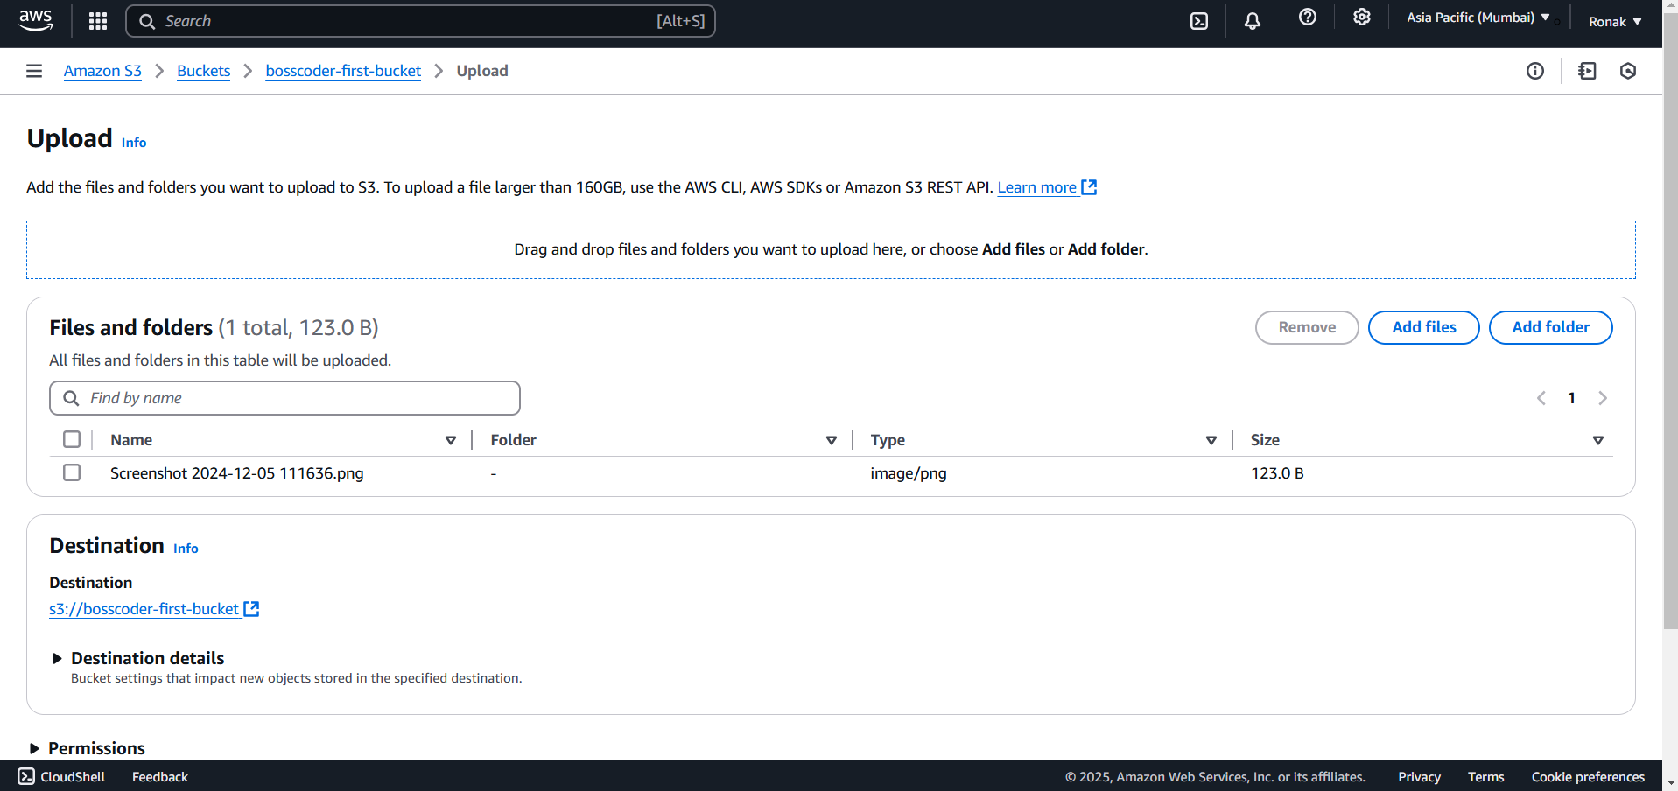
Versioning in S3:
- Versioning is a feature in Amazon S3 that allows you to keep multiple versions of an object in the same bucket.
- It protects against accidental overwrites and deletions by maintaining a history of all versions of objects.
- When versioning is enabled, every object stored in the bucket gets a unique version ID.
Features of Versioning:
- Object History:
  - Retains all versions of an object (current and previous).
  - Allows recovery of overwritten or deleted objects.
- Default Behavior:
  - When versioning is first enabled, all existing objects receive a null version ID.
  - New objects get a unique version ID.
- Delete Marker:
  - When an object is deleted, a delete marker is created instead of removing the object.
  - The delete marker becomes the current version, making the object appear deleted.
- Suspension:
  - Versioning can be enabled, suspended, or disabled.
  - Once enabled, it cannot be fully disabled, only suspended.
Steps for versioning:
Step 1: Go to the Bucket for which you want to enable versioning
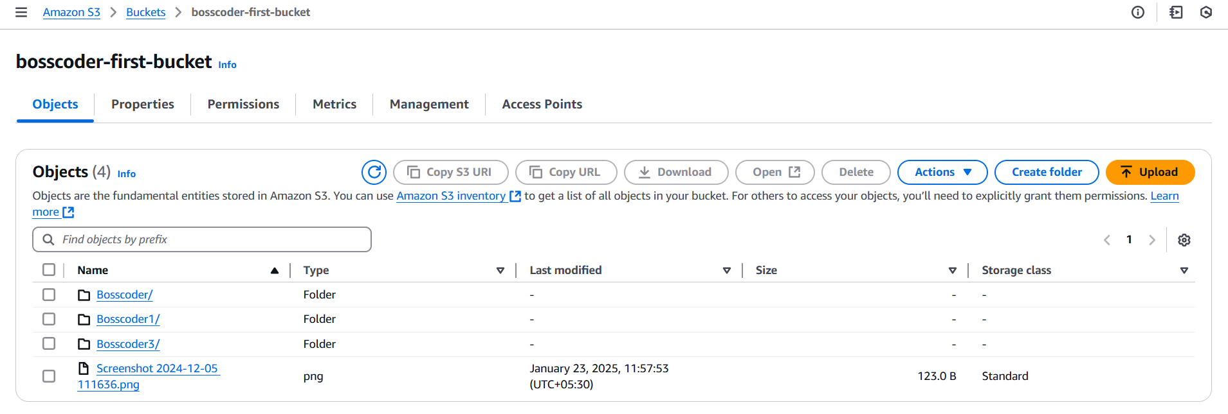
Step 2: Go to Properties tab and under it go to Edit option of Bucket versioning and change setting from Suspend to Enable and then Save changes.
Cross-Region Replication:
Cross-Region Replication (CRR) in AWS is a feature of Amazon S3 that automatically replicates objects between buckets in different AWS Regions. This enables you to maintain copies of your data in geographically dispersed locations, which can be beneficial for disaster recovery, compliance, or performance optimization for users in different locations.
Key Features of Cross-Region Replication (CRR):
- Automatic Replication: Replicates new or updated objects in the source bucket to the destination bucket in another region automatically.
- Versioning Requirement: Both source and destination buckets must have versioning enabled.
- Cross-Account Support: Can replicate objects between buckets in different AWS accounts.
- Selective Replication: You can use bucket policies or replication rules to filter which objects should be replicated (e.g., by prefix or tags).
- Replication of Metadata and Permissions: Includes copying object metadata and Access Control Lists (ACLs).
- Storage Class Options: Allows you to replicate objects to different storage classes in the destination bucket (e.g., Standard-IA, Glacier).
Steps to Set up CRR:
Step 1: Open the Bucket and go to Management tab
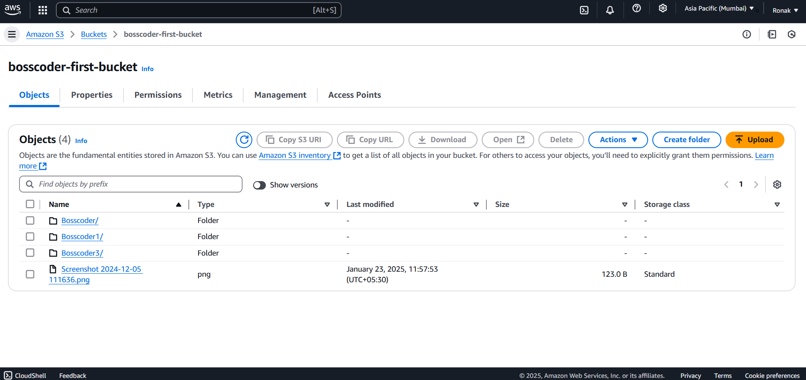
Step 2: Now, go to Replication rules.
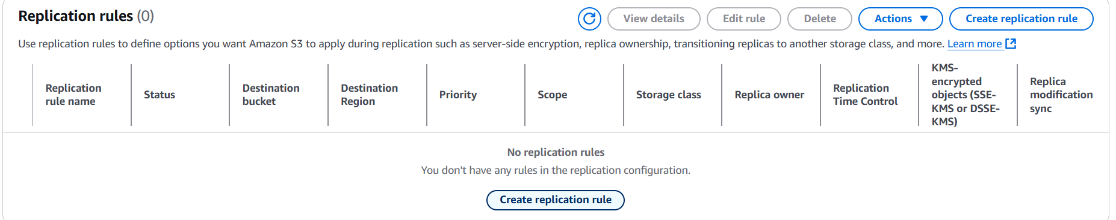
Step 3: Now, add the Rule name.
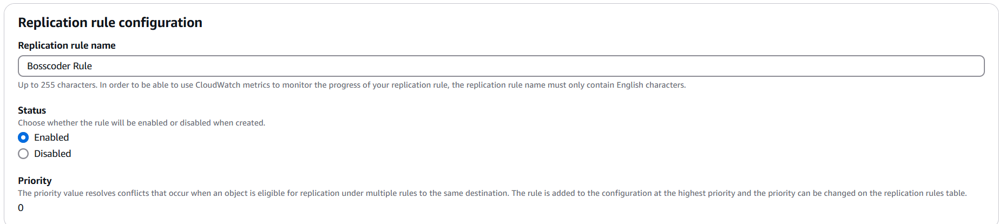
Step 4: Now, add Filter type.
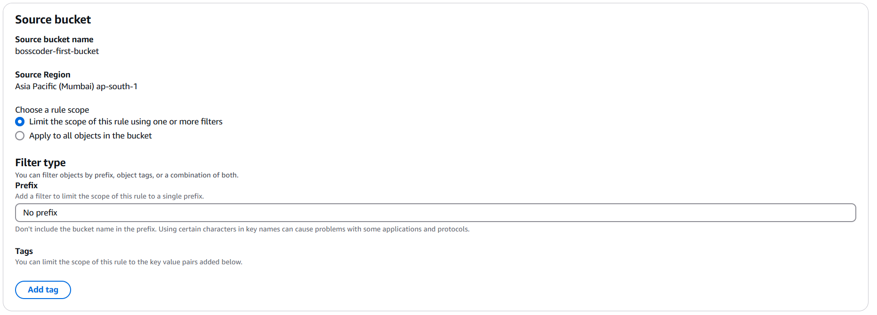
Step 5: Now, add Destination.
NOTE: The Bucket should not be same as the Destination Bucket.
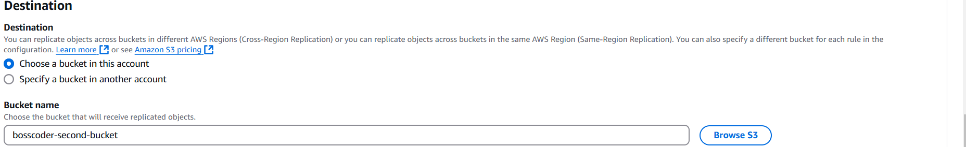
Step 6: Then, choose the IAM rule as per you.
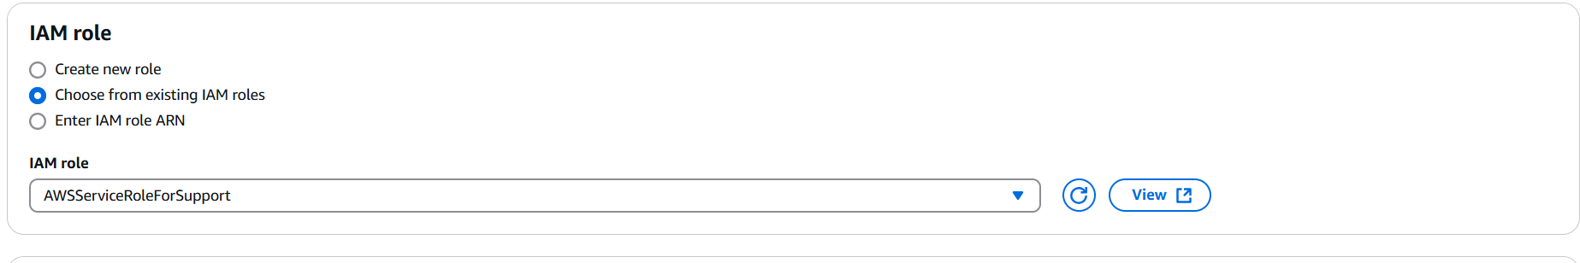
Step 7: You can also add the Destination rules
Step 6: After this, you can save and CRR has been set up.
Transfer Acceleration:
Amazon S3 Transfer Acceleration is a feature of Amazon S3 that speeds up content uploads and downloads by utilizing Amazon CloudFront's globally distributed edge locations. It provides an optimized path for data transfer to and from an S3 bucket, especially for long-distance or high-latency network connections.
Key Features of S3 Transfer Acceleration:
- Global Edge Network:
  - Uses Amazon CloudFront edge locations to accelerate data transfer.
  - Automatically routes traffic to the closest edge location.
- Reduced Latency:
  - Optimizes the network path between the user and the S3 bucket, minimizing latency.
- Simple Setup:
  - Enable Transfer Acceleration on an S3 bucket with a single click or API call.
- Secure Transfers:
  - Fully supports SSL/TLS for secure communication.
  - Compatible with S3’s security features like bucket policies, ACLs, and encryption.
- Automatic Fallback:
  - If Transfer Acceleration is not faster than standard transfer, it falls back to the regular S3 path without any manual intervention.
Steps to Enable Transfer Acceleration:
Step 1: Open the Bucket already created.
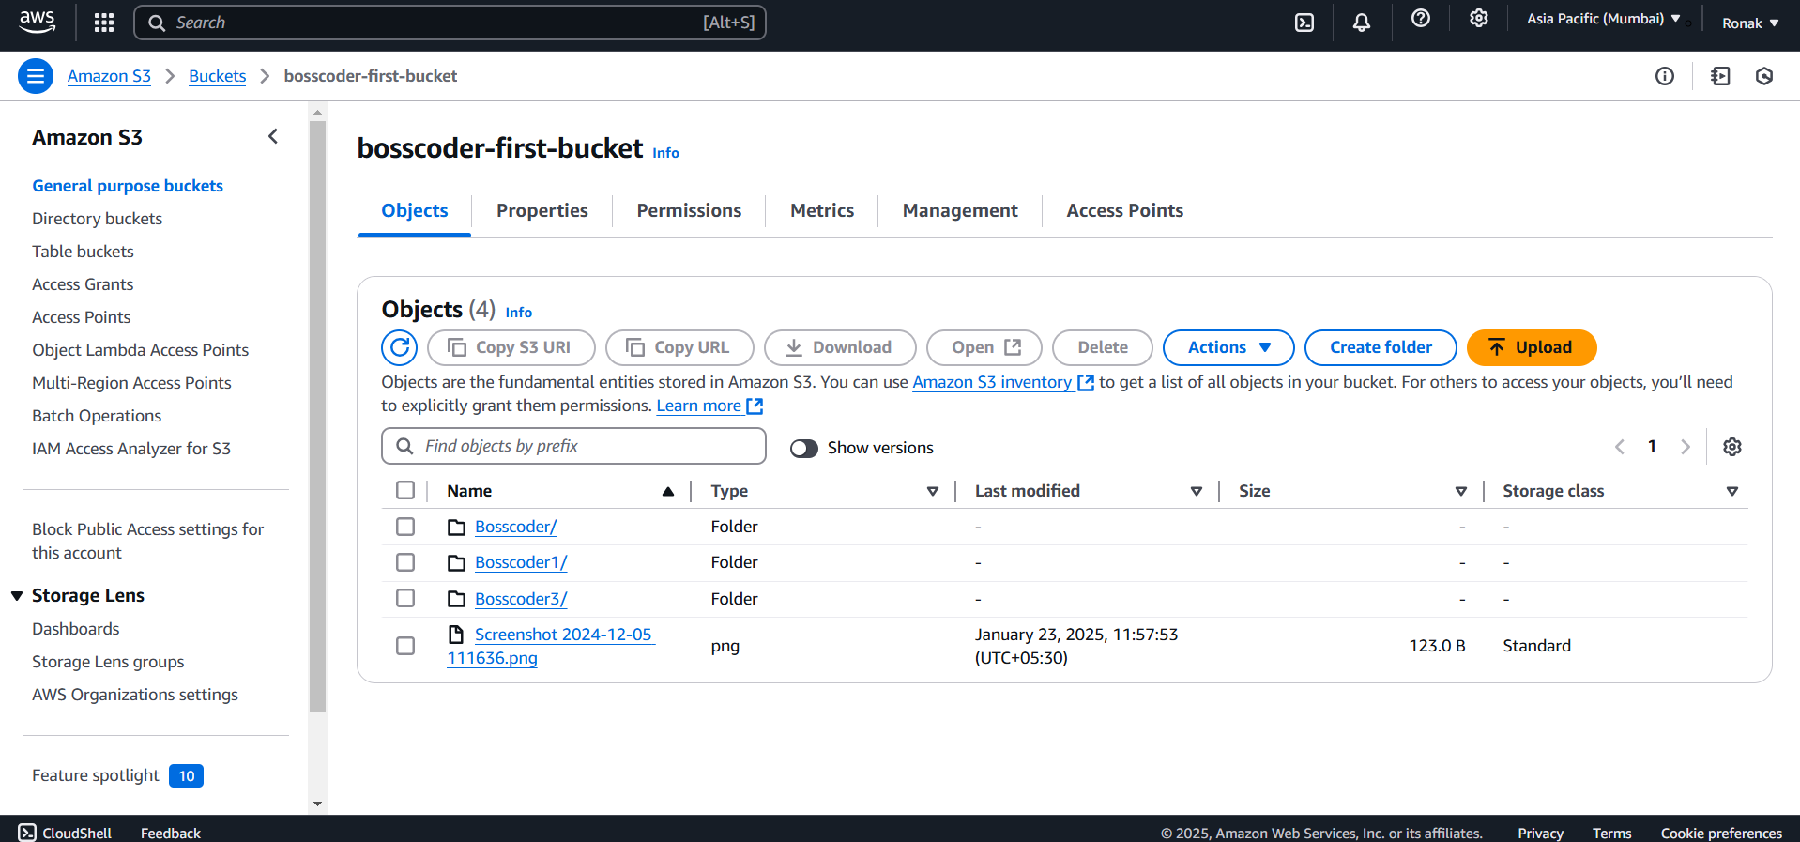
Step 2: Now, go to the Properties tab and search for Transfer Acceleration and click on Edit.
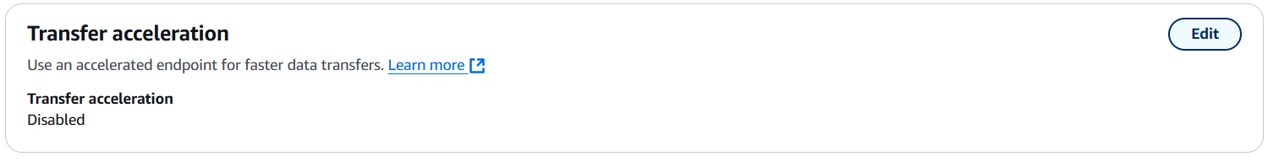
Step 3: Enable the Transfer Acceleration and an Accelerated endpoint will be generated, use this for uploads and downloads to leverage Transfer Acceleration
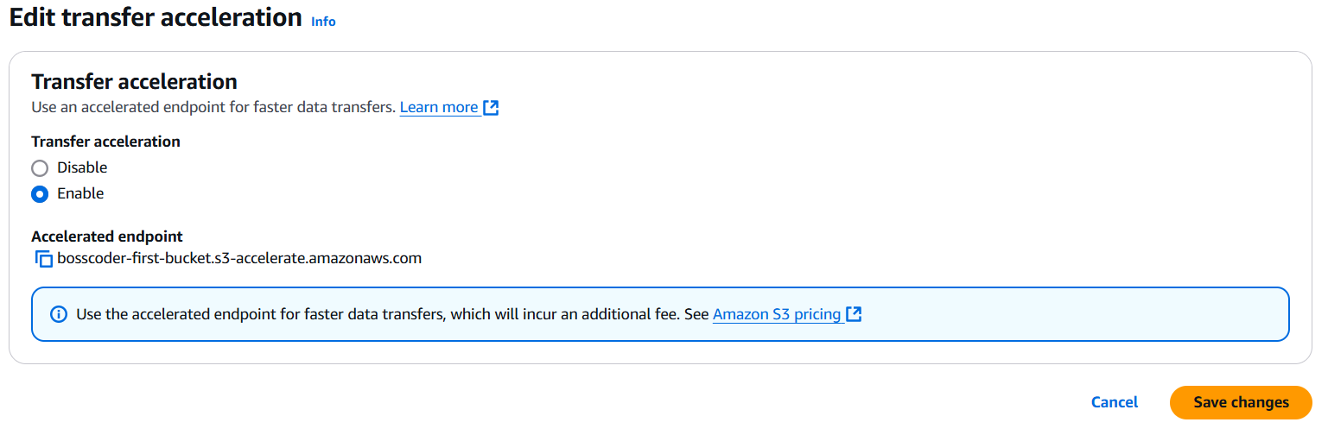
DNS:
DNS (Domain Name System) is a critical component of the internet that acts as a directory service. Its primary role is to translate human-readable domain names (like www.example.com) into machine-readable IP addresses (like 192.0.2.1), which computers use to locate and communicate with each other.
Key Functions of DNS:
- Domain-to-IP Mapping: Converts user-friendly domain names to IP addresses.
- Load Balancing: Distributes traffic across multiple servers to ensure high availability.
- Email Routing: Uses DNS records like MX (Mail Exchange) records to direct email to the correct mail servers.
- Service Discovery: Identifies services, such as FTP or database servers, in distributed systems.
Components of DNS:
- DNS Resolver: The client-side system (often part of the operating system) that queries DNS servers.
- Root Name Servers: The top-level DNS servers that direct queries to the appropriate top-level domain (TLD) servers (e.g., .com, .org).
- TLD Name Servers: These manage domains for specific TLDs and direct queries to authoritative servers.
- Authoritative Name Servers: Store the actual DNS records for a domain (like A, CNAME, and MX records).
Working of DNS:
- A user types a domain name into their browser.
- The browser sends a request to a DNS resolver (usually provided by the user's ISP).
- The resolver checks its cache for the domain. If not found:
  - It queries a root name server.
  - The root server refers to a TLD name server.
  - The TLD server refers to the authoritative server for the domain.
- The authoritative server responds with the IP address.
- The resolver sends the IP address back to the browser, which uses it to connect to the website.
DNS Records:
1. SOA (Start of Authority) Records
- Stores information about the domain's DNS zone.
- Contains:
  - Primary name server supplying data for the zone.
  - Zone administrator's contact details.
  - Version of the DNS data file.
  - Time-to-Live (TTL): Determines how long a record is cached. Lower TTL ensures quicker propagation of changes.
  - Secondary server update intervals and expiry times.
2. NS (Name Server) Records
- Used by TLD servers to route traffic to authoritative DNS servers.
- Example Workflow:
  - The user queries the IP address of hindi100.com.
  - ISP checks .com TLD and retrieves the NS record.
  - TLD directs the query to ns.awsdns.com (Name Server).
  - Name Server resolves the query to the corresponding IP address.
3. A (Address) Records
- Maps a domain name to an IPv4 address.
- Example: www.example.com → 123.10.10.80.
4. TTL (Time-to-Live)
- Specifies how long DNS records are cached (measured in seconds).
- Lower TTL: Faster updates and propagation of changes.
- Example: A website with a TTL of 60 seconds will reflect changes in 60 seconds.
5. CNAME (Canonical Name) Records
- Maps one domain name to another.
- Example:
  - m.devices.com → mobile.devices.com.
  - Users accessing either domain will reach the same website.
6. Alias Records
- Maps domain names to AWS resources like:
  - Elastic Load Balancers (ELB).
  - CloudFront distributions.
  - S3 buckets configured as websites.
Amazon Route 53:
Amazon Route 53 is a scalable and highly available Domain Name System (DNS) web service provided by AWS. It connects user requests to infrastructure running in AWS—like EC2 instances, Load Balancers, or S3 buckets—and can route users to infrastructure outside AWS. Additionally, Route 53 supports domain name registration.
Features of Route 53:
- Domain Registration:
  - Register new domains directly through Route 53.
  - Manage domain settings such as contact information and renewal preferences.
- DNS Routing:
  - Translate human-readable names (e.g., www.example.com) into IP addresses that computers use to connect.
  - Supports various routing policies like Simple, Weighted, Latency-based, Geolocation, Geoproximity, and Failover.
- Health Checking and Monitoring:
  - Automatically monitor resources such as web servers and application endpoints.
  - Redirect traffic to healthy resources in case of failure.
- Traffic Flow:
  - Provides a visual editor for routing policies to create sophisticated DNS configurations.
- Integration with AWS Services:
  - Works seamlessly with AWS resources like S3, CloudFront, and Elastic Load Balancer.
  - Can automatically update DNS records when infrastructure changes.
- Scalability and High Availability:
  - Designed for high reliability using globally distributed DNS servers.
  - Resilient against DNS-based attacks, like Distributed Denial of Service (DDoS) attacks.
- DNSSEC Support:
  - Provides security for DNS by adding a layer of authenticity to DNS records.
Key Components of Route 53:
- Hosted Zone:
  - A container for DNS records that define how traffic is routed for a domain or subdomain.
  - Types:
    - Public Hosted Zone: Used for domains accessible from the internet.
    - Private Hosted Zone: Used for internal AWS resources.
- Record Types:
  - A (Address): Maps a domain to an IPv4 address.
  - AAAA: Maps a domain to an IPv6 address.
  - CNAME (Canonical Name): Maps one domain to another.
  - MX (Mail Exchange): Routes email to a mail server.
  - TXT: Contains arbitrary text, often used for verification (e.g., SPF records).
  - NS (Name Server): Specifies authoritative name servers for a domain.
  - SRV: Provides information about services (e.g., VoIP).
  - PTR (Pointer): Used for reverse DNS lookups.
- Routing Policies:
  - Simple Routing: Default policy; maps a single domain to a single resource.
  - Weighted Routing: Distributes traffic based on assigned weights to resources.
  - Latency-based Routing: Routes traffic to the region with the lowest latency.
  - Failover Routing: Automatically redirects traffic to a healthy resource if the primary fails.
  - Geolocation Routing: Routes traffic based on the user’s geographical location.
  - Geoproximity Routing: Routes traffic based on user proximity to resources, with bias adjustments.
  - Multivalue Answer Routing: Returns multiple IP addresses and performs health checks.
- Health Checks:
  - Monitor the health of endpoints (e.g., web servers or applications).
  - Supports HTTP, HTTPS, and TCP protocols.
  - Can integrate with CloudWatch for monitoring and alerts.
Working of Route 53:
- Domain Registration:
  - Register a domain with Route 53 or transfer an existing one.
  - Route 53 automatically creates a hosted zone with default NS (Name Server) and SOA (Start of Authority) records.
- DNS Management:
  - Create DNS records in the hosted zone to define how traffic should be routed.
  - Point the domain to AWS resources (like an EC2 instance or S3 bucket) or external endpoints.
- Routing Traffic:
  - Based on the configured routing policy, Route 53 determines where to send user requests.
- Health Monitoring:
  - Continuously monitors endpoints using health checks.
  - Automatically removes unhealthy endpoints from DNS responses.
Use Cases:
- Global Application Deployment:
  - Use latency-based routing to route users to the nearest region for better performance.
- High Availability:
  - Implement failover routing to ensure minimal downtime during failures.
- Cost Optimization:
  - Distribute traffic using weighted routing to optimize cost or balance workloads.
- Custom Domain for AWS Services:
  - Map custom domains to S3 static websites or CloudFront distributions.
Route 53 Dashboard:
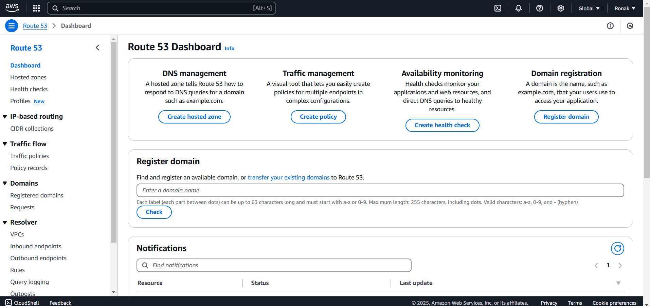
Functions which can be performed through Route 53:
1. DNS Management
- Manage DNS records for your domain names.
- Key Functionality:
  - Configure hosted zones to control how DNS queries for your domain are routed.
  - Hosted zones define the mappings between domain names and resources such as IP addresses or AWS services.
- Steps: Click on "Create hosted zone" to define DNS settings for a domain.
2. Traffic Management:
- Control and optimize traffic flow to your resources across multiple endpoints or AWS regions.
- Key Functionality:
  - Create traffic routing policies based on latency, geographic location, or endpoint health.
  - Useful for load balancing and disaster recovery configurations.
- Steps: Click on "Create policy" to define traffic management rules.
3. Availability Monitoring:
- Monitor the health of your applications and resources.
- Key Functionality:
  - Set up health checks to ensure that traffic is routed only to healthy endpoints.
  - Monitor applications and automatically redirect traffic if resources become unavailable.
- Steps: Click on "Create health check" to set up health checks.
4. Domain Registration:
- Manage and register domain names directly through Route 53.
- Key Functionality:
  - Search for and register available domain names.
  - Transfer existing domains from other registrars to Route 53 for centralized management.
- Steps: Enter a domain name in the input box and click "Check" to verify its availability.
5. Notifications:
- Track the status and updates related to Route 53 resources and activities.
- Key Functionality:
  - View important alerts or notifications about your Route 53 setup.
  - Check resource-specific updates or issues.
Additional Options in the Side Menu:
A. IP-Based Routing
- Configure CIDR collections for specific routing scenarios based on IP ranges.
B. Traffic Flow
- Manage traffic policies and records to customize routing rules for complex use cases.
C. Domains
- Registered Domains: Manage the domains you own.
- Requests: Track the status of domain registration and transfer requests.
D. Resolver
- Configure DNS resolvers to route traffic between AWS and on-premises environments.
- Key Features:
  - Set up inbound and outbound endpoints.
  - Define rules and enable query logging.
Hosted Zone:
A hosted zone is a collection of DNS information. These records describe how you want to route traffic for the nominated domain and it’s subdomains.
A hosted zone has the same name as the primary domain and can be either a public or private hosted zone.
A public hosted zone describes how you want to route traffic for the domain in the public internet while a private hosted zone defines how you want to route traffic in a private AWS VPC.
Steps to create Hosted Zone:
Step 1: Go to Hosted Zone and click on Create Hosted Zone
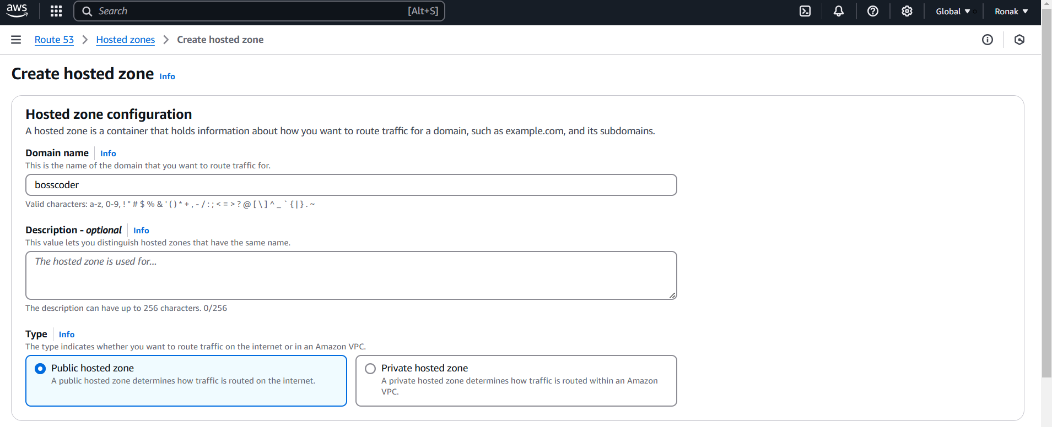
Step 2: Now, select the Type of Hosted Zone.
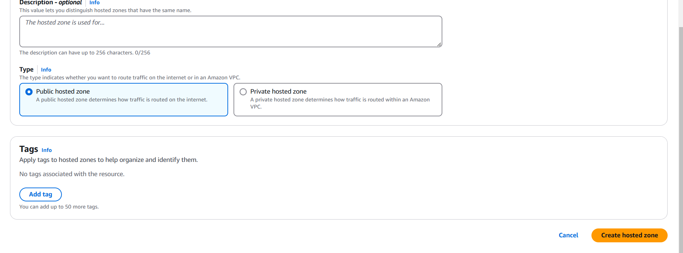
Step 3: Select VPC and then the hosted zone is created.
